In this lesson before we can actually can spawn the platform We will make the platform fall whenver ball goers away from it
Lets say we have a platform and whenever the ball passes the platform and goes to next platform We want that platform to fall down so eventually all the platform (I think it means small platform and not the big platform )falls down and get destroyed
Since we want o do that for all the platform
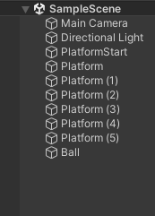
So we try for one platform aand we can copy that component to all the platform(who knows)
select any one platform and then press f to focus on this

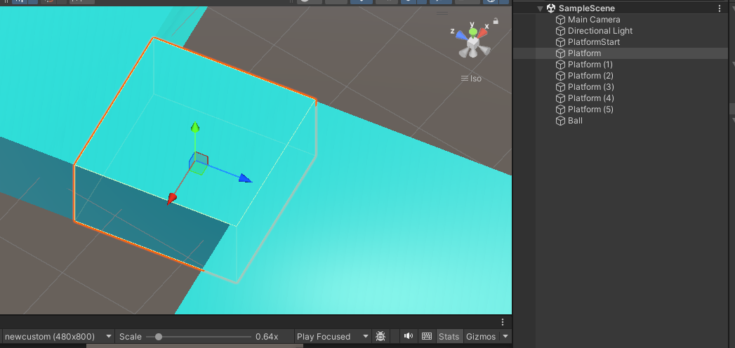

So now we are going to make a new empty object as the child of a the platform IOA and attach collider to it
So we can do that by selecting the IOA inside and then right click on it and in the menu opened click on the Empty object
Now an empty object is made inside the object or IOA in the heirarchy panel and we will name it TriggerChecker and the job of this. So the job of this is to check the trigger between the ball and this TriggerChecker empty object
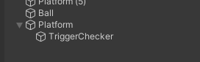
So whenever the trigger happens and when the ball goes out of it(platform) we want the platform to fall down
Now in TriggerChecker we add the component to it that is box collidor in physics submenu of add component
Now we check the istrigger so that the ball can go through it

Note:-
Since the emptyobject is inside a parent so when we add a collidor to it then its collidor will have the dimension equal to its parent(I think it will be possible when the parent is normal structure like cube, cuboid(I don't know))

We need to position empty object TriggerChecker at the top position of the platform so we can detect whenever teh ball goes away from it So for that we edit TriggerChecker collidor by
going ot its insopector and then click on the edit Collidor as marked below

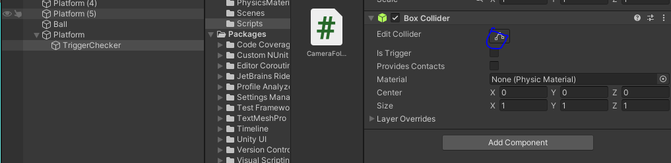

Now after clicking on it

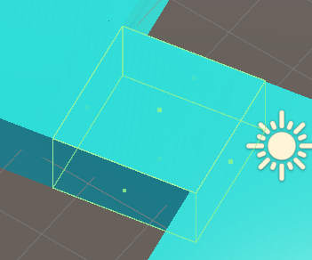

By using the green dot we stretch the collidor by dragging the green dot along the axis the side is pointed to
So we stretch the dot on top face in the vertical direction
like below
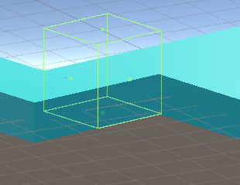
and also drag up from the bottom
Now it will be like below
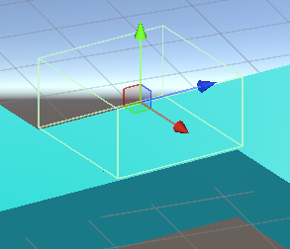
Now the empty object is present above the platform and have length and breadth equal to platform
Now we can check that when when teh ball goes out of it
So when the ball goes through it he trigger can check when the the ball comes in it , when the ball goes through it and when the ball goes out of it
So whern the ball goes out of it the we want to simple call a function which will make this platform fall down
We now will add the rigidbody component to the parent platform IOA who has an empty object TriggerChacker as a child
Now add a script to it with the name TriggerChecker
Now inside the script we redefine teh function that is onTriggerExit
This method is automatically called by unity when an object will be out or exit from this trigger
It takes a paramter of type Collidor this parameter is the gme object that has collided with this trigger and gone out of this trigger

Tell me if both the object that are about to collide in unity how will they behave if one of them has istrigger checked and How will thay behave when both of them is istrigger

In Unity, the behavior of objects with colliders (whether set as Is Trigger or not) can be influenced significantly by whether the Is Trigger option is checked on the colliders. Here's a breakdown of how objects will behave in different scenarios:

1. One Object with Is Trigger Checked (Trigger Collider)
When one of the colliders has the Is Trigger property checked:
- The object with the Trigger collider: The collider will not physically block or stop the movement of the other object. It will simply detect that the other object has entered its space, and you can use OnTriggerEnter(), OnTriggerStay(), and OnTriggerExit() to detect and respond to these events.
- The other object: The other object will behave like a normal collider (i.e., it will still interact with the physics engine). If it collides with the trigger collider, it will pass through without being stopped or affected by the trigger. However, it will generate trigger events for the object with the trigger collider.
So, the object with Is Trigger checked will only detect the other object, not physically collide or stop it. The other object can pass through the trigger but still activate trigger events.

2. Both Objects with Is Trigger Checked
When both colliders have Is Trigger checked:
- Neither of the colliders will behave as a solid object in terms of physics, meaning that neither will block the other or stop the movement.
- Instead, Unity will treat both colliders as triggers, and both will only detect when they overlap.
- This will generate trigger events on both objects, which you can handle via OnTriggerEnter(), OnTriggerStay(), and OnTriggerExit() methods.
In this case, both objects will pass through each other freely, and you will only receive trigger events indicating they have overlapped, but no physical collision will occur.

Summary:
- One Is Trigger and One Normal Collider: The normal collider will pass through the trigger but still generate trigger events. The trigger won't physically block the other object.
- Both Is Trigger: Neither object will physically interact, and both will pass through each other. Trigger events will be generated.
Let me know if you'd like more details or code examples on how to handle these events!
so the other object can block the triggered object

Yes, you're right—the object with a regular collider (without Is Trigger checked) can block the object with a trigger collider.
To clarify:
- The triggered object (the one with Is Trigger checked) won't block the other object; it will only detect the overlap and trigger events.
- The other object (the one without Is Trigger checked, i.e., a regular collider) will behave normally and can block or stop the triggered object if it collides with it.

Scenario Breakdown:
- Object A (Trigger Collider): It will not block anything. When another object enters its collider, it can detect that with trigger events (e.g., OnTriggerEnter), but it won't physically stop or block the other object.
- Object B (Regular Collider): This object will block or stop movement if it collides with another object. So, if Object B has a regular collider and moves toward Object A, Object B will block the movement of Object A if their colliders overlap.

Example:
If you have an object (say a ball) that has Is Trigger checked, and it moves toward a wall (with a regular collider), the wall (regular collider) will stop the ball from passing through it. However, the ball won't block the wall—it will simply detect the overlap and generate the trigger events on the wall.
In short, the object without Is Trigger checked can block the object with Is Trigger checked. The trigger object will pass through solid objects but will activate trigger events when they overlap.
Let me know if this clears up the behavior!
Now inside OnTriggerxir we check it the object is ball or not
and then make the platform fall down. The fall down logic will be in seperate function that is FallDown of return type void
and we will call inside the if condition which is used to check if the detected object is Ball(we check it through tag )
So inside the FallDown function we will on the gravity of platform IOA due toi which teh platform will fall down without our adding any force top it.
Now the TriggerChecker script is attached to the TriggerChecker empty object and it is a child of
of platform IOA aand RigidBodyy component is attached to the platform IOa
So waht we can do is there ius a function similar to getComponent in which bwe can get the components attacehd to parent parent
its name is getComponentInParent
and when we get the componenet we set iuts property use gravity to trie
So our snippet of code will look like this

GetComponentInParent<Rigidbody>().useGravity = true;

Now after it we will attach the tag "Ball" to the Ball IOA
and then add this Ball IOA in the script
Now we don't want to call the Falldoen function immediately so we want to call it after few seconds with the help of function called Invoke
it take the two argument
One argument take the name of the function in string that we want to call after few seconds
and in second argument we tell after how many seconds we want to call the function whose name passed we passed in other argument
So snippets will be like below

Invoke("FallDown", 0.5f);

One more thing we need to do is whenver the platform falls down we want to destroy it after few seconds
otherwise the platform will fall doen for infinite amount of time aand will not be destriyed be automtically
We can access the parent game object (or parent IOA) by using
transform.parent.gameObject
________________________________________________________________________________
Note:-
If you destroy the parent(IOA) then the parent will be destryed along with its child gameObject(IOA) but if you destroy the child ________________________________________________________________________________

By using Destroy function we can destroy game object after some seconds as well
The snippets will look like below

Destroy( transform.parent.gameObject , 2f);

So after two seconds our falling platform will ber destroyed
Now our code will look like below
TriggerChecker.cs

using System.Collections;
using System.Collections.Generic;
using UnityEngine;

public class TriggerChecker : MonoBehaviour
{
// Start is called before the first frame update
void Start()
{

}

// Update is called once per frame
void Update()
{

}
private void OnTriggerExit(Collider col)
{
if (col.gameObject.tag == "Ball")
{
Invoke("FallDown", 0.5f);
}
}
void FallDown()
{
GetComponentInParent<Rigidbody>().useGravity = true;
Destroy( transform.parent.gameObject , 2f);
}
}

Now next we will make these platform spawn randomly and will create a simple aalgorithm for that
We can do that in next lesson.

